Education en France
IR: Le Système Scolaire en France
http://parlons-francais.tv5monde.com/webdocumentaires-pour-apprendre-le-francais/Memos/Culture/p-584-lg0-Le-systeme-scolaire-francais.htm

Key Word Recognition. Find the French words/phrases that best express the meanings of the following English words/phrases.

1. nursery school ______________________
2. middle school______________________
3. elementary school student______________________
4. middle school student______________________
5. high school______________________
6. high school student______________________
7. college student ______________________
Main Idea. What is the main idea of this article? Answer in English.
____________________________________________________________________________________________________________________________________________________________________________________
Supporting Details.
1. Check each detail that is mentioned in the article (not all are included).
2. Fill in the information that is given for each detail you have checked. Write in English.
___ The number of students who took the bac in 2011 ______________________
___ The number of students who passed the bac in 2011 ____________________
___ The percentage of students who took the general bac ___________________
___ The percentage of students who took the technology bac ________________
___ The percentage of French young people who have a bac __________________
___ The percentage of French young people who have a brevet, but not a bac ____________
___ The percentage of French young people who don’t have any diploma ________________
___ The percentage of French students who earn their bac, but don’t go to college ________________
___ The percentage of French college students who drop out before they get a degree __________________
Guessing Meaning from Context. Find the underlined words/phrases and write what you think they mean in English.
1. La scolarité est obligatoire ___________________
2. sans aucun diplôme _____________________
3. 25% arrêtent dès la première année ____________________
Le Système Scolaire en France : Vocabulaire Utile
(Notez les mots importants qui viennent de la discussion !)

IC : Discutez avec un partenaire. Comparez les deux systèmes d’enseignement : les Etats- Unis et la France. Quelles sont les similarités et les différences

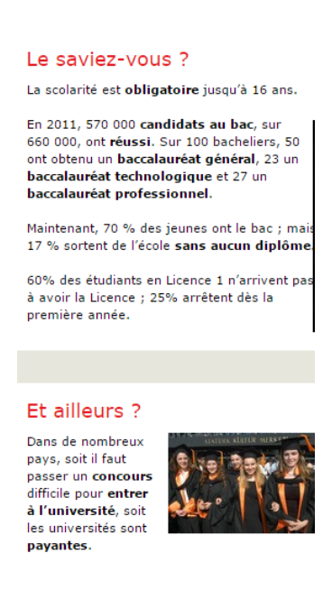
Que veut dire:

- L’enseignement supérieur –
- Un concours
- La scolarité
- Un bachelier
- Un candidat

Quels sont les 3 types de bac?
*
*
*

