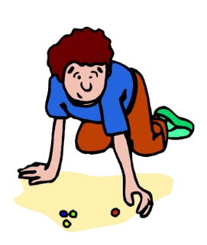
Français III
IPA- Unit 2 : Ma Vie Avant et Maintenant
Scenario: You have signed up to help our French Club with a group of elementary-aged, French-speaking kids who have recently arrived. They don’t speak English and you want to make them feel at ease here as much as possible—and practice your French while you’re at it! You will be comparing childhood memories with your classmates to “get in the mindset,” then creating an electronic storybook to introduce yourselves to the kids. You will compare your lives now to what they were like when you were kids.
I. Presentational Writing: Create an electronic French children’s storybook to highlight your childhood and compare with your life today. You will be sharing them with your incoming group! Make sure you are “digging deeper” and using more complex sentences to showcase what you know! You will need 8-10 topics comparing the two periods of your life and photos or images on each page. They do not have to all be photos of you, but they should help us understand what you are saying.
Comment était ta vie avant et comment est-elle maintenant ? Pensez aux grandes idées. Il faut au moins 15 contrastes avec de bons détails !
- L’école les animaux les amis les vacances les peurs le savoir
- Les jeux la nourriture les livres les voyages la mode les croyances
- La famille la maison/la ville l’apparence les rêves/les souhaits la technologie
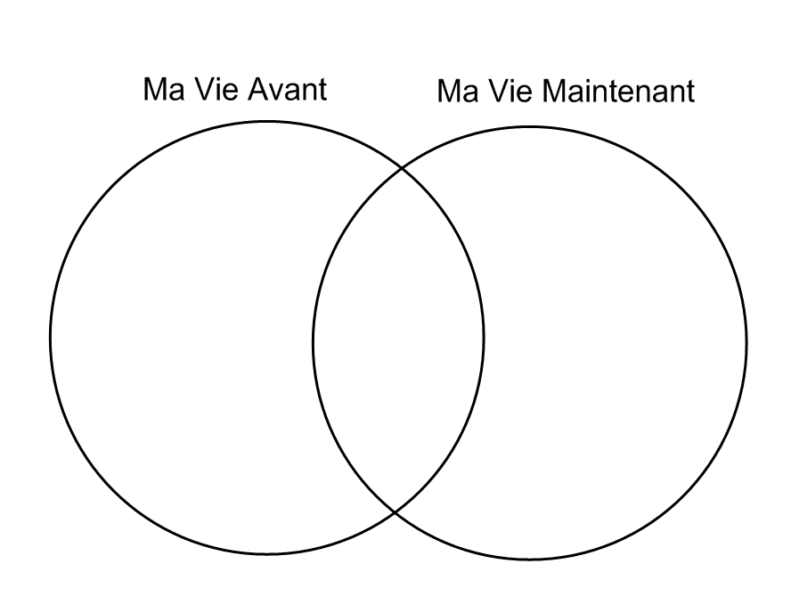

II. Interpersonal Communication: Listen to the storybook presentations and ask follow-up questions to get more information as you listen. Play the role of a French friend. What else do you want to know about the lives you hear? You should plan to ask at least 3-4 questions during the presentations. If you are presenting, be prepared to answer! You can think about what you might ask, but it is not rehearsed speaking. Since this is not rehearsed, mistakes are OK. Just use what you’ve learned and stay in French.
III. Interpretive Listening/Reading: Listen to and read about French people discussing their childhoods and answer comprehension questions to show your understanding. Activities will include defining key words from our lesson, comprehension questions based on context and interpretation, and making cultural comparisons. What do today’s kids have in common with those from the past? What similarities are there between American and French kids?
Presentational Writing: Childhood Story Book comparing life now to childhood
HONORS: Create an electronic French children’s storybook to highlight your childhood and compare with your life today. You should include:
- 8-10 topics/activities comparing the two periods of your life and photos/images on each page (present vs imparfait)
- French “time words” to help us understand the frequency
- More complex sentences to showcase what you know

 | Meets Expectations  Intermediate-Low:  4 | Meets Expectations  Novice-High:  3 | Approaches Expectations  Novice-Mid:  2 | Below Expectations  Novice-Low:  1
Task  How well do I complete the task?  - 8-10 comparisons  - 2 events described  - Photos/illustrations for each comparison  - Visually appealing! | ALL 4 ITEMS included and done very well! | 3 ITEMS included and done fairly well. | 2 ITEMS included and done fairly well. | Only ITEM done well.
Vocabulary Use  How extensive and applicable is my vocabulary?  vocab/expressions from this lesson and past units | - I consistently use extensive vocabulary to complete the task.  - Vocab/expressions from this unit on every set of pages. | - I use adequate vocabulary to complete the task.  - Vocab/expressions from this unit on almost all pages. | - I use limited and/or repetitive vocabulary.  - Vocab/expressions from this unit on most pages. | - I use extremely limited and/or repetitive vocabulary.  - My native language interferes.
Language Control  How accurate are my grammatical structures?  imparfait /present | - I make 0-2 grammatical errors in basic structures.  - I demonstrate emerging use of verb tenses and some advanced grammatical structures. | - I make 3-4 grammatical errors in basic structures and attempt to use some advanced grammatical structures. | - I make 5-7 grammatical errors in basic structures and rarely attempt to use advanced grammatical structures. | - Extensive mistakes in grammatical structures (more than 7 mistakes).
Communication Strategies  How well do I organize my writing? | - My writing is well-organized.  - My main ideas are supported with examples and elaboration.  - There is a variety of sequencing and transition words. | - My writing is organized.  - My main ideas are supported with some examples.  - There are some sequencing and transition words. | - My writing is somewhat organized.  - My main ideas are not supported with examples. | - My writing is not organized.  - Information is presented randomly.
Mechanics  How accurately do I use correct spelling, capitalization, and punctuation? | - I make no or almost no errors in spelling, capitalization, and punctuation. | - I make occasional errors in spelling, capitalization, and punctuation (3-4) | - I make frequent errors in spelling, capitalization, and punctuation.  - (5-7) | - I make little or attempt to use correct spelling, capitalization, and punctuation.

HONORS:

20 = 100
19= 98
18= 96
17= 94
16= 90
15= 88
14= 85
13= 82
12= 79
11= 76
10= 73
9= 70
8= 60

